**GAME2005 - Game Physics – Assignment 2 Report**

**Question:** *A metal crate has a mass of 12.8 kg, and is sitting at the top of a frictionless ramp with a rise of 3m and a run of 4m.*

**Part A)** *Compute the free body diagram of the loot crate at time 0*

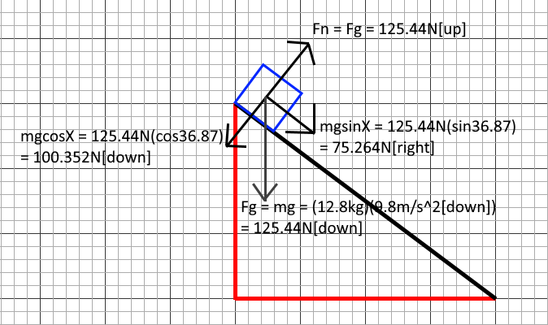

**Part B)** *Compute the net force and the acceleration of the loot crate at time 0. Given the frictionless surface what do we know about the acceleration as the object moves down the ramp?*

From the frictionless surface the loot crate is sitting on, we know that there is no force of friction being applied to the crate as it slides down the ramp, and therefore the acceleration of the crate is directly based off the gravitational force (and acceleration, 9.8m/s²) applied to the crate, with the only coefficient being the angle of elevation the ramp is sitting at. With this information applied, it means the gravitational force on the crate in the X direction is the net force in the x axis, and therefore is the only force we need to calculate.

The crate is not moving in its y-axis, meaning that the crate is at equilibrium, and the net force in y axis is 0. Therefore, in order to find the total net force on the crate, we only need to find the net force of X to get the total net force on the crate. However, we need to find the acceleration of the crate first before we can find the force. We can do this by equating the net X force () to *ma,* since we know from Newton’s second law that .

🡪 🡪

After equating the net X force to *ma* and cancelling out mass, we now have an equation to find the crate’s acceleration, however, we need now need to find theta before doing so, which in this context, is the angle of elevation for the ramp. The problem gives us the dimensions of the ramp to the ground, having a rise of 3m and a run of 4m. If we assume that these dimensions, and the ramp, form a right-angle triangle with the ground, we can use some basic trigonometry to find theta. Of the three trig functions, we need to use the one that with the rise (X) and run(Y) of a triangle, which is exactly what uses, so will use this equation to solve for theta.

🡪 🡪 🡪

Now that our angle of elevation has been found, we can plug this value into our acceleration equation from before, and use the acceleration to find the total net force exerted on the loot crate.

🡪 🡪

🡪 🡪 🡪

Therefore, when at that top of the ramp, the acceleration of the crate is and the Net Force on the crate is 75.264N (right).

**Part C)** *Consider the loot crate as it leaves the ramp and moves onto a flat surface that now has some friction. Compute the free body diagram for this situation. If coefficient of kinetic friction is 0.42 (steel on steel), calculate the new net force and acceleration.*

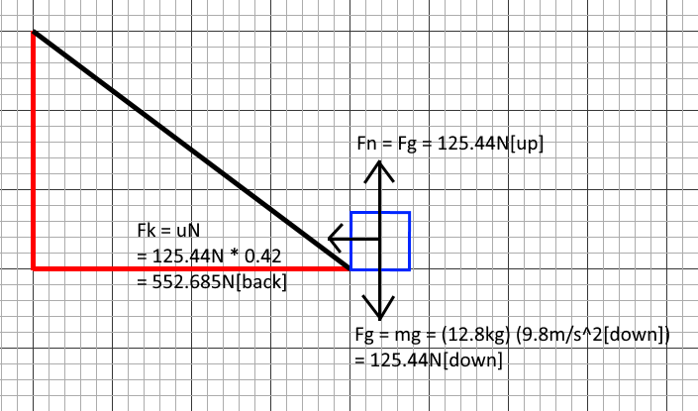

There are a few changes to the forces applied on the crate when it is on flat ground as opposed to the inclined plane. The crate now sits on a surface with a coefficient of friction, and therefore now has a force of friction working against it, as opposed to the ramp, which had no force of friction acting upon it. This force is kinetic friction, as the crate makes contact with this surface as it is already in movement. Because this surface is flat instead of inclined, the force of gravity no long has an effect on the net X force, leaving the force to friction to be the only force applied to the net X force. The box still remains in equilibrium in the y-axis, meaning the net Y force is still 0, and therefore the total net force is based on the net X force, being the force of friction.

Like last time, we need to find acceleration before we can find the net force. Like last time, we can use Newton’s second law to equate the net X force to *ma.* Since we just established that the net X force is also equal to the force of friction, we can equate the two expressions to each other and solve.

🡪 🡪

*Note that the force of friction is negative because it is working against the current direction of the crate.*

We can break down this equation further, but we need to find the normal force first. We know that the normal force is the reaction that the crate causes when it exerts downward forces onto the surface, and therefore has the same force as all the downward forces applied to the crate. Since the only downward force on the crate is the force of gravity, we can conclude that . Therefore we can now substitute the force of gravity into the equation above, solve for acceleration, and finally solve the net force.

🡪 🡪 🡪 🡪 🡪

🡪 🡪 🡪

Therefore, on the flat surface, the acceleration of the crate is and the Net Force on the crate is 52.685N left (or -52.685N).

**Part D)** *If we assume that the force of friction is constant after this point, how long will it take for the loot crate to stop moving? At what distance in meters will the loot crate stop?*

There are 2 kinematic equations we can look at to help us solve this: 1) The equation for final velocity with constant acceleration: , and the final displacement of an object (or particle) in terms of velocity and acceleration: . We can re-arrange the first equation to help us find our time, and substitute that value into our second equation to find our distance. However, in both of these equations, we need to find the initial velocity first, and so we need to backtrack to the first part of the problem to solve this. Assuming there was no interference in the velocity of the crate when it left the ramp and came into contact with the flat surface, the initial velocity of the crate on the flat surface is the same as the final velocity of the crate on the ramp. Therefore, this value should be found first.

We can use both the equations above to help us find the final velocity of the crate in the ramp with the information we have. If we assume the loot crate was initially at rest, then and .

What we are missing is , or in this context, is the length of the ramp. This can be easily found using the Pythagorean theorem, since the problem has already given us 2 sides: the rise and run:

🡪 🡪 🡪

We can now use the displacement equation from earlier to add our values, and rearrange the equation to find time.

🡪 🡪 🡪 🡪 🡪 🡪

It takes 1.304 seconds for the crate to slide down 5m on the ramp. We can use this value in the final velocity equation from earlier to get the crate’s final velocity on the ramp, which we established is the same as the crate’s initial velocity on the flat surface.

🡪 🡪

This is the velocity that the crate leaves the ramp at as it comes in contact with the floor, however there is one more step we must perform: Because the ramp is on an angle, this final velocity is a magnitude of both the x and y velocities that the loot box experiences as it slides. When it slides on the flat ground, its y-velocity is lost, and all that remains is the x velocity, meaning we need to get the final velocity’s x component in order to determine the rate at which the loot box slides along the ground. We can do this by simply multiplying the final velocity with the cos of the elevation angle.

🡪 🡪

We now have the initial velocity of the crate on the flat surface. For our final velocity, we can assume that the crate will have travelled its maximum distance when it has stop, therefore . Since we already have our acceleration as well, we can re-arrange our final velocity equation from before to solve for time. But before we solve for time, we need to split the velocity into its components, as we require the velocity in the x plane to properly calculate time and distance.

🡪 🡪 🡪 🡪

Now that we have our time, we can use the same displacement equation as before to find the final distance the crate travelled, and substitute the variables from before.

🡪 🡪

Therefore, after sliding onto a flat surface with a 0.42 coefficient of friction, the loot crate will stop moving after 1.491s at a distance of 4.574m away from the ramp.